Answer all three of the following questions per work of art shown below. You should reference your book to aid you in answering these questions. Answers should be in essay format, be a minimum of three-five sentences each, and include at least three terms from the glossary for each work.
- “Painting”
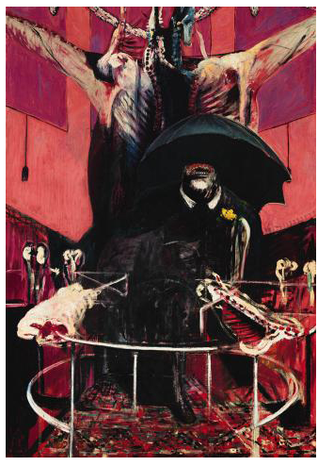

  - Who is the artist?
  - Which event does this respond to and what statement does it make?
  - What may have inspired the image of the male figure?
- “Flowers on Body”
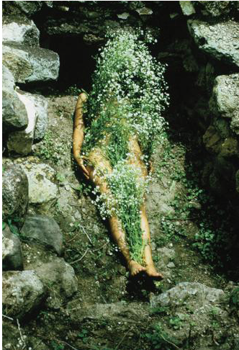

  - What issues did this artist address in her work?
  - What series does this particular image belong to?
  - What themes does this image address?
- “Backs”
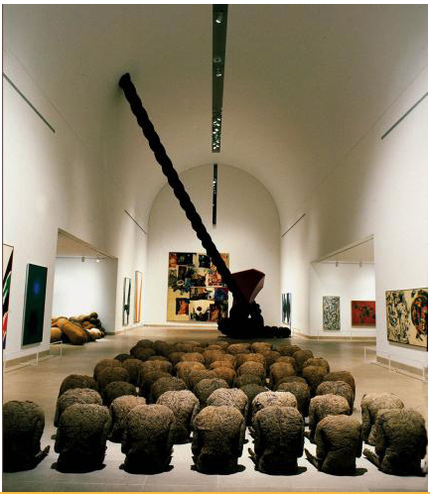
- What materials did the artist use in her works?
- How is this representative of her work?
- What do the forms suggest in this work?

